Agenda for Today:
- Topics from Last Week
- Migration Summary
- Update on Automation
- Curtisswright.com
  - Walkthrough of Weekly Web Analytics of Curtisswright.com
    - Google Analytics: Link
Summary Report For Migration Websites (Batch 3):
Website | Owner | Completed Tasks | Upcoming Tasks | Clarifications/Requests
CW Phase 2.0 - Planning | Sai Krishna V | Received pptx file from Darren.  Had a detailed discussed with CW-Defense understood their requirements  We analyzed the requirement of CW-defense  CW Defense — DS Web 2.0 : Requirements via Implementation - 20 Topics - Internal (To be shared with Dave)  Based on Weekly Discussion with the defense team, we are working on migration planning on merging Curtisswright.com and CW defense.  We will look at all the schema, data objects, and forms and do a detailed technical analysis on the merger of these two sites (including conflicts, issues, and naming or taxonomy changes).  Defense Analysis :  CW Web2 - Migration_Plan - DS | Internally discussed the design standards.  Creating a Drupal theme (CSS, JS specific to 2.0 mockups) will be installed on the 2.0 development site.  (Figma > Drupal Theme)  ---  Approved Templates by End of March 2026  (After Exec Review, Dev Starts by April 7th 2026) | CW 2.0 Menu - Live Mockup : https://www.figma.com/proto/t7KTn7Ej7vEzlJymIsHYWE/Curtiss-Wright-Web-2.0?node-id=3272-3690&viewport=-33585%2C-860%2C0.35&t=22moO7kQjY1dhRgd-1&scaling=min-zoom&content-scaling=fixed&starting-point-node-id=3272%3A3690&page-id=2093%3A2  Acquia environment setup for CW phase 2 ✅  https://cw-2-0-sandbox.curtisswright.com/sensors  CW Theme 2.0 ✅ (theme name : cw_2, cw_2_sub)  Modules ✅  Design ☑️  Phase 2.0 - Homepage Design preview Curtiss-Wright Phase 2.0 - Home page.pdf  CW 2.0 Header Navigation UX process.pdf  Figma file link:  CW 2.0 Navigation changes - Option 1  Web Phase 2.0 _ Navigation Corporate + Division.pdf  Brand Guide is completed ☑️  Curtiss-Wright Design product pages Web 2.0.pdfCW Web-2.0 Style guide updated.pdf  Style Guide_abbreviated.pdf (CW Copy)  We have reviewed the CW Style Guide.
CW Phase 2.0 : CW Common Theme Development | Sunil Kumar | Created all Components ✅  - Completed Product and inner pages ✅  - Completed Home, Markets and Products Pages.  - All content is now editable using Layout Builder components.  - Completed the mapping of content types, site structure, navigation, Views, and the header and footer.  - Recreated the existing site using Layout Builder components.  - Login page designed. | Checking the functionality of all components for reuse.  Testing is work in progress ☑️  It will be completed by 6th Oct. | https://cw-2-0-sandbox.curtisswright.com/sensors  https://cw-2-0-sandbox.curtisswright.com/cw-2-0-components-home  Is there any new format or template for the News and Events inner pages that we should follow?
Web refresh | Britto Raj Shilpa Patil Divya MSunil Kumar | Curtiss-Wright -Completed and sent for review ✅  EMS - Completed and sent for review ✅  Valves - Completed and sent for review ✅  Sensors - Completed and sent for review ✅  Nuclear Completed and sent for review ✅  Surface Tech - Completed and sent for internal review ☑️  Actuation - Completed and sent for review ✅  Industrial - Completed and sent for review ✅ |  | - CWST testing is going on.☑️  It will be completed by the 5th OCt.
Surface Technologies Translation Sites/Content | https://surfacetechnologies.curtisswright.com/  Nihar / Sindhu | Completed the translations for the French, Polish, Spanish, Chinese, and German languages. ✅ | Completed Translation Pages: 249/249 | Phase 2.0:  Completed the Hungarian language translations and sent for review.✅
Surface Technologies - Searchable Approvals Database | Divya M | TG Approvals 2025 | Ref : https://www.valencesurfacetech.com/approvals/  https://cwstcomstage.prod.acquia-sites.com/searchable-database | Send the first set of data for review.  Amanda shared a few modifications regarding the location search. I am currently reviewing the requirements and checking the possibilities for implementing them.
Searchstax | Rohan Gurav |  | A custom module is developed. ✅  https:/curtisswright.com/search | Analytics Report  INC0227363  We are updating the latest cw_search module across all environments.  Live on:  Industrial  Surface Technologies  EMS  Actuation  Valves
SEO Optimisation for curtisswright.com | Sofia Krishnan | - Completed the Technical SEO audit of Surface Technologies regional location pages and shared the recommendation plan.✅ | - Working on optimizing page meta titles, description for the Surface Tech site. (Ticket No :INC0224386) (255/842) | Sofia is working on the SEO Analysis of CW Business Sites (We have completed Surface Tech earlier)
Curtisswright.com  Careers Military Pathway Mockup | Divya M |  | https://curtisswrightcomstage.prod.acquia-sites.com/careers/militarypathways | Working on the Military Pathway mockup based on the modifications shared by Melanie.
CW Actuation Portal  https://portal.cw-actuation.com/  Live ✅  Monitoring and Supporting | Rohan Gurav | Live: portal.cw-actuation.com |  | Learning Management System (LMS) is completed ✅ and currently waiting for the IT block to be released.  LMS Training Portal - Feature Delivery & Task Tracker-Hold☑️  Working on the Price Configurator changes requested by Bonnie. ✅  Working on the CMS for the Supportive Information section to allow admins to edit the pages themselves. ☑️  Exlar Order Status files have not been received since September 22. ⚠️
Everlube | Divya M | everlubeproducts.com | Everlube Site Summary Document | Evaluation of the site is completed and sent for review. ✅  No updates this week.
IMR test Labs  http://imrtest.com/ | Shilpa Patil | IMR Site Summary Document  Completed Layouts : 02/52  Completed Pages Migrated: 0/182 | Pending layouts: 50/52  Pending Pages : 182/182 | No updates this week  Migration will start after 2.0 web refresh.
Keronite | Britto Raj | keronite.com | keronite Site Summary Document | Evaluation of the site is completed and sent for review. ✅  No updates this week  Migration will start after 2.0 web refresh.
Nuclear | Sunil Kumar | - Integrate ultra.energy (cwic.curtisswright.com)  - Integrate 3keysoft.com / ws-corp.com  - Integrate cw-connect.com  - Evaluate store.ultra.energy (cwicstore.curtsisswright.com) | WS-Corp Site Summary Document | It's on hold.

Topics from Last Week
Topic | Details | Question/Clarification/Update
Few Low Priority Topics |  | CW October 2026 Events and PR ?  - Q3 2026 announcement press release ✅  - Business wire API ?
Bluefly Topics  Accessibility & SEO Improvements  Performance Optimization | Rasheed suggested CW SEO Topics and Scope. | CW <> Bluefly <> Etag - Topics Tracker  - Security and Drupal Core Updates ✅  - CSP headers (Javascript + CSP Best Practices) - Working on Nuclear dev site as per Rasheed guidance to fix font and style src hashing ☑️  - Autodiscover and missing blocks ☑️  - Working on Press release Date appending with title for all press releases on live site. (Completed year - 2002 to 2020) ☑️ - Will be continued after 2.0 web refresh  - Webform Module: The Counter Problem ☑️ (Testing few Drupal modules to implement Queuing process) - Will be continued after 2.0 web refresh
Drupal 10 EOL by December | Drupal 10 to be updated to 11 | All sites will be updated to Drupal 11 after completing web refresh 2.0 ☑️

Analytics, Monsido, and Webmaster Console:

Analytics | https://analytics.google.com/analytics/web/#/p432579895/reports/intelligenthome
Webmasters Console | https://search.google.com/search-console?utm_source=about-page&resource_id=sc-domain:curtisswright.com
Monsido (Acquia Optimize) | https://new.monsido.com/

Analytics
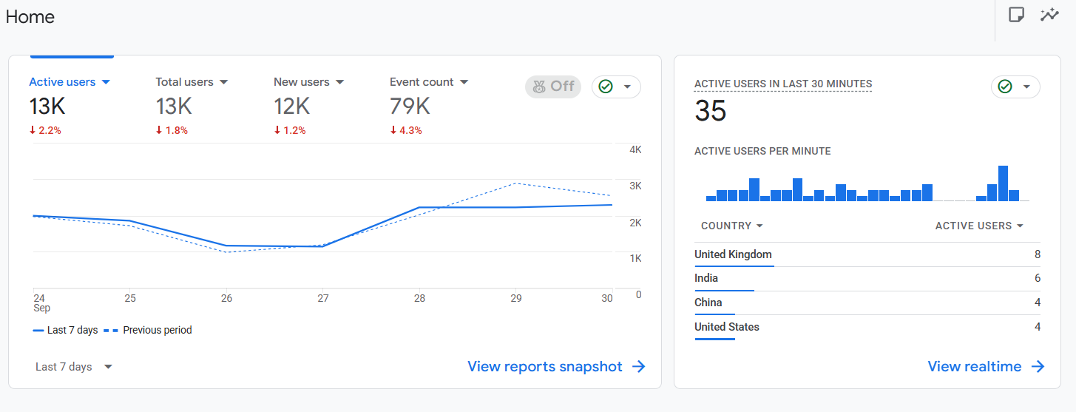
Monsido

